arcenterfornursing@gmail.com
https://www.facebook.com/arcenterfornursing/
http://www.arcenterfornursing.com/index.html

Nursing Education Guide for Prospective Nursing Students

Arkansas Center for Nursing, Inc.

Preface

As part of a national program to encourage young men and women to consider a career in nursing, this Nursing Education Guide for Prospective Nursing Students was prepared for Arkansas school counselors at the middle and high school levels. This guide provides a variety of current information about the nursing profession including statistics, types of nursing programs in Arkansas, and a list of nursing schools by region. It is intended to be a resource for counselors, student and parents.

A task force of nursing education experts convened by the Center for Nursing at the Foundation of New York Nurses, a grantee of the Academic Progression in nursing grant, prepared the original guide for school counselors in New York State. Permission was granted from Deborah Elliott, Executive Director of the Center for Nursing at the Foundation of New York Nurses, to the Education Committee of the Arkansas Center for Nursing, Inc. to adapt and modify the guide for Arkansas school counselors.

New York APIN School Counselors Resource Guide Expert Task Force
Contact:
Deborah Elliott, MBA, BSN, RN
Executive Director, Center for Nursing at the Foundation of NY Nurses, Guilderland, NY delliott@fNY.org

Education Committee, Arkansas Center for Nursing, Inc.
Contact:
Dr. Crystal Rose, PhD, MHA, RN, CNE
Dr. Katie Camden, DNP, RN
Dr. Brenda Trigg, DNP, GNP, RN, CNE
Tri-Chairs, Education Committee, Arkansas Center for Nursing

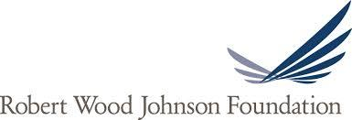

TABLE OF CONTENTS

Why Nursing? 2
Where do nurses work? 3
Importance of School Counselors 4
Talking to Middle and High School students about Careers 5
Typical coursework required in a nursing program 6
Nursing school readiness 6
Types of Nursing Professions in Arkansas 7
Different Scope of Practice for LPNs and RNs 8
Licensed Practical Nursing 9
Registered Nursing 10
What is expected of the professional nurse 11
Average salaries of nurses in Arkansas 12
Men in the nursing profession 12
Dispelling myths about nursing 13
Approved Nursing Programs in Arkansas 14-26
What is the National Council Licensure Exam (NCLEX) 27

WHY NURSING?

A nursing career offers many wonderful opportunities
Nursing is a career filled with endless personal and professional rewards. Nurses save lives, provide comfort and reassurance to patients and their families during the most frightening and tragic situations, and share in the joys of birth, recovery and survival. Nurses make a difference in all that they do - it is no wonder they are time and time again considered the most trusted profession as cited by the annual Gallup poll on a regular basis. When young men and women choose a career in nursing they are choosing to spend their lives helping others, using skills that blend scientific knowledge with compassion and caring. There are few professions that offer such a rewarding combination of high tech and high touch.

Nursing is a blend of science and technology with the art of caring and compassion. Nursing professionals provide preventative and restorative health care to patients in a variety of settings. Every day on the job nurses use the science they learned in nursing school and take continuing education courses throughout their careers to keep up with the latest in the medical and nursing sciences. Nurses work to promote health, prevent disease, and help patients cope with illnesses. Nursing is a science that requires in-depth knowledge, skills and understanding. Nursing deals not only with a person's biological needs, but their psychosocial, societal and cultural needs as well. Nurses work closely with doctors and other health care professionals, and serve as the advocates for patients and families.

➢ Registered nurses constitute the largest healthcare occupation, with almost 3 million RNs nationwide.
➢ Approximately 280,000 registered nurses (RNs) and 70,000 licensed practical nurses (LPNs) are licensed to practice in Arkansas.
➢ About 50% of nursing jobs are in the acute care setting (hospitals), while the rest of the jobs are spread out among numerous settings including schools, outpatient and ambulatory care centers, home care, organizations, government, etc.

According to the U.S. Bureau of Labor Statistics (BLS) Nursing is one of the top five professions projected to experience a 19% increase in job growth through the year 2022. Additionally, as baby boomers retire, the U.S. BLS predicts a need for at least 525,000 nurses to replace the existing nursing workforce. (http://www.bls.gov/news.release/ecopro.t08.htm)

WHERE DO NURSES WORK?

Nurses work in many settings and specialty areas: taking care of adults, families, geriatric patients, premature babies, maternity patients, serving the military, patients with cancer, school children, office workers, college students, homeless people, sports teams, psychiatric patients, and other settings. Here is a list of 50 settings where nurses are hard at work:

1. Ambulatory care  2. Camp nurses  3. Entrepreneurs  4. Flight nurses  5. Forensic specialists  6. Informatics specialists  7. Inventors  8. Journalists  9. Legal consultants  10. Parish nurses  11. Peace Corps volunteers  12. Wound care specialists  13. Birth Centers  14. Blood Banks  15. Call Centers  16. Case management  17. Clinics  18. Daycare centers and Head Start programs | 19. Diabetic clinics  20. Dialysis Centers  21. Federal, State and local health department  22. Publishers and as writers  23. Indian Health Service  24. World Health Organization  25. Hospitals  26. Occupational and employee healthcare  27. Flu clinics  28. Government facilities  29. Home care  30. Hyperbaric/bariatric settings  31. Research activities  32. Simulation labs  33. Beauty industry as medical esthetics nurses  34. Insurance industry | 35. Military: US Army Nurses, US Navy Nurses  36. Medical equipment manufacturers  37. Nursing homes  38. Cruise ships  39. Oil rigs  40. Set of movie and television productions  41. Pharmaceutical Companies  42. Physicians’ offices  43. Private practice  44. Professional Associations  45. Public Health  46. Positions in nursing leadership  47. Red Cross  48. Retail clinics  49. Schools and Academic settings  50. Travel nursing

THE IMPORTANCE OF SCHOOL COUNSELORS

School Counselors can be very influential when helping college-bound students select a program of study. Counselors bring a wide range of knowledge and skills to the conversation and can help students identify their own areas of interest, their academic and personal strengths, and potential areas of study where they may excel. Suggestions for what Counselors can do to introduce the option of nursing to their students are:

➢ Suggest nursing as a career option to students who excel or have an aptitude for science and math studies;

➢ Invite a local nurse or nursing student to speak at a career day;

➢ Offer a nursing scholarship or award at graduation;

➢ Place a display in the school about the variety of employment opportunities with a nursing career;

➢ Arrange for a high school student to spend a day on a college/university campus with a nursing student;

➢ Arrange for a high school student to spend a day shadowing a nurse at his or her place of employment;

➢ Encourage interested students to talk with the school nurse about his/her nursing education and nursing career experience;

➢ Provide the resources enclosed in this tool kit to interested or prospective students.

TALKING TO MIDDLE and HIGH SCHOOL STUDENTS ABOUT CAREERS

Youth who are most likely to think about their future careers, and believe that they have a variety of career options, have high self-esteem and are able to understand and evaluate complex career information. They have families that help them learn about career choices and support their efforts, in school and outside, to prepare for a career.

But some adolescents have difficulty seeing a connection between what they learn in school, and how they behave there, and their future careers. Students who are not able to meet with a guidance counselor may not know what they need to do, and which courses they should take, in order to make their plans for the future a reality. As a result, some students who expect to go to college do not take the courses necessary for college enrollment. Unfortunately, poor students are least likely to think about how their middle and high school course choices can limit their career plans later. They may also have less family support because of all the stresses created by poverty.

Unfortunately, many youth have already limited their career aspirations by the time they reach middle school, based on false information and beliefs. For example, many boys may have sex-stereotyped views of occupations by the time they reach adolescence. Girls also acquire these views, but at a slightly older age.
- Explore with students how they can successfully live and work in a culturally diverse world.
- Help students recognize their interests, aptitudes, and abilities, and understand adult roles.
- Help students understand the broad scope of work and career possibilities available currently and in the future.
- Help students broaden their aspirations beyond the stereotypes of gender, socioeconomic status, and ethnicity.
- Integrate vocational and academic education to promote intellectual development, and the acquisition of higher level think and problem-solving skills.
- Assist with students' development of social skills, personal values, and self-esteem.
- Work with families to support their children's career aspirations.
TYPICAL COURSEWORK REQUIRED IN A NURSING PROGRAM

Courses taken in nursing school include some general education courses in language arts and math as well as courses in statistics, anatomy/physiology, microbiology, chemistry, psychology, sociology, history, foreign language, humanities, and computer science. In addition, all nursing programs include specialized courses in pharmacology, nutrition, fundamentals of nursing, medical-surgical, pediatrics, obstetrics/gynecology, psychiatric/behavioral health. Bachelor level programs provide courses in community health, health policy, nursing theory, and leadership.

NURSING SCHOOL READINESS

Aspiring nurses should have strong academics, particularly in math and science courses, in order to be successful in nursing school. Many nursing schools require a placement test which evaluates your reading, math, science and critical thinking skills. Some nursing schools will require SAT/ACT scores as part of their admission criteria. Requirements vary for each school so it is important to check with the school you are interested in applying to find out if they require other courses or prerequisites.

Course work in high school should include English and language arts, math and sciences, especially biology, and chemistry. Admission to nursing school is competitive and a high school grade point average does matter. Many candidates will be at an advantage if they have Advanced Placement Courses (AP) or concurrent courses on their transcript.

As with any application to a college or university, participation in extra-curricular activities such as sports, music, theatre, clubs and community service will enhance your application.

TYPES OF NURSING PROFESSIONS IN ARKANSAS
There are four (4) types of nursing professions in Arkansas that require a license.
There are over 52,000 licenses issued by the Arkansas Board of Nursing in the following categories:

•RN - Registered Nurse

•LPN - Licensed Practical Nurse

•LPTN - Licensed Psychiatric Technician Nurse

•APRN - Advanced Practice Registered Nurse
- CNP - Certified Nurse Practitioner
- CNM - Certified Nurse Midwife
- CRNA - Certified Registered Nurse Anesthetist
- CNS – Certified Clinical Nurse Specialist

After completing basic nursing programs, RNs and LPNs must pass nationally standardized examinations. LPTNs must have passed a state licensure exam.

To be licensed as an APRN, an RN must complete a graduate-level or post-graduate-level advanced practice nursing program and hold certification from a Board-approved nationally recognized certifying body.

DIFFERENT SCOPE OF PRACTICE FOR LPNs and RNs
Licensed Practical Nurse (LPN) | Registered Nurse (RN)
Job duties LPN Job Duties RN
Provide basic medical and nursing care such as checking blood pressure and inserting catheters, ensure the comfort of patients by helping them bathe or dress, discuss health care with patients, and report status of patients to registered nurses and doctors. | Administer medication and treatment to patients, coordinate plans for patient care, perform diagnostic test and analyze results, instruct patients on how to manage illnesses after treatment, and oversee other workers such as LPNs, nursing aides, and home care aides.
Education LPN Education RN
You must complete an accredited practical nursing program which usually takes about one year to complete. These programs are most often taken at technical or community colleges. Courses usually combine academia in nursing, biology, and pharmacology, in addition to supervised clinical experiences. | Two educational options are available: a bachelor's of science in nursing (BSN) and an associate's degree in nursing (ADN) from an approved nursing program. BSNs usually take four years to complete, whereas ADN programs usually require two to three years to complete. All programs include courses in social, behavior and physical science in addition to clinical experiences in various workplaces.
Licensing LPN Licensing RN
After completing your practical nursing course from a state-approved program, you'll receive a certification in practical nursing. Once that is completed, you must take the National Council Licensure Examination (NCLEX-PN) in order to obtain a license and be able to work as an LPN. | All registered nurses require a nursing license acquired by completing a state-approved nursing program and passing the National Council Licensure Examination (NCLEX-RN). Some RNs may choose to become certified through professional associations in certain specialties. Certification is usually voluntary, but some advanced positions require it.  Advanced Roles  Advanced roles for RNs are available with additional education, such as nurse educator, clinical nurse leader, nurse administrator, nurse informaticist. Some may require an advanced APRN license, such as a nurse practitioner.

Sources: U.S. Bureau of Labor Statistics 2016-17 Occupational Outlook Handbook; Licensed Practical and Licensed Vocational Nurses; Registered Nurses.

LICENSED PRACTICAL NURSING (LPN)

Some registered nurses begin their nursing careers as licensed practical nurses (LPNs). Practical nurse education usually consists of approximately one year of academic and clinical education. At the conclusion, the graduate practical nurse is awarded a practical nurse certificate, and is eligible to take the NCLEX-PN licensure exam.

Licensed practical nurses must work under the supervision of a registered nurse, a physician or other licensed health care professional. LPNs often are employed in doctors' offices, clinics, nursing homes, or rehabilitation facilities.

LPNs may be eligible to continue their education in nursing to become registered nurses. Often, qualified practical nurses enter associate degree nursing programs; some enter baccalaureate programs. In certain instances, they may be given credit for their practical nursing education and may take advantage of advanced placement opportunities. Requirements for advanced placement vary from school to school, and may involve demonstrating knowledge through examinations and skills through demonstration.

Certain associate degree programs participate in LPN-to-RN tracks for education progression. These Arkansas programs may give qualified LPNs 6 credit hours in nursing, and may advance place these candidates to streamline their progression. In this instance, the LPN must take a PN-to-RN Transition course, which is offered at these institutions. The Transition course focuses on the transition from the role of the practical nurse to the role of the registered professional nurse.

Source: http://www.nursingworld.org/EspeciallyForYou/What-is-Nursing/Tools-You-Need/RNsAPNs.html

REGISTERED NURSING (RN)

According to the American Nursing Association (ANA), nurses have many responsibilities, such as:
- Perform physical exams and health histories
- Provide health promotion, counseling and education
- Administer medications, wound care, and numerous other personalized interventions
- Interpret patient information and make critical decisions about needed actions
- Coordinate care, in collaboration with a wide array of healthcare professionals
- Direct and supervise care delivered by other healthcare personnel like LPNs and nurse aides
- Conduct research in support of improved practice and patient outcomes

Settings: RNs practice in all healthcare settings: hospitals, nursing homes, medical offices, ambulatory care centers, community health centers, schools, and retail clinics. They also provide health care in more surprising locations such as camps, homeless shelters, prisons, sporting events and tourist destinations.

Source: http://www.nursingworld.org/EspeciallyForYou/What-is-Nursing/Tools-You-Need/RNsAPNs.html

HOW DOES SOMEONE BECOME A REGISTERED NURSE?

Associates Degree (2 years as a full time student)
- Usually 2-3 years depending on when and how you complete pre- or co-requisites* (25-30 credit hours of general education courses)
- After completion of the program, you are eligible to take the RN licensing exam called the NCLEX-RN
- After completion of an associate degree program, you would need to apply to a RN→BSN program to obtain further education for broader job opportunities.

Bachelor’s Degree (4 years as a full time student)
- Typically a 4 year program but can be done over several years part time
- Many BSN programs offer online and weekend/night class options
- You would receive nursing education along with a general education with English and history courses (49-52 credit hours)
- You would be eligible to take the RN licensing exam (NCLEX-RN) after completing the 4 year curriculum.
- BSN degree allows you more job opportunities and easy transition to graduate school

1+2+1 AS and BS Degree
- 4 year program
- You would receive nursing education along with a general education courses
- You would receive AS degree after 3rd year
- You would be eligible to sit for NCLEX after the 3rd year and be able to work as an RN during last year of school
- You would receive BSN degree after the 4th year

*Pre- and co-requisites include: Chemistry, Anatomy and Physiology, Microbiology

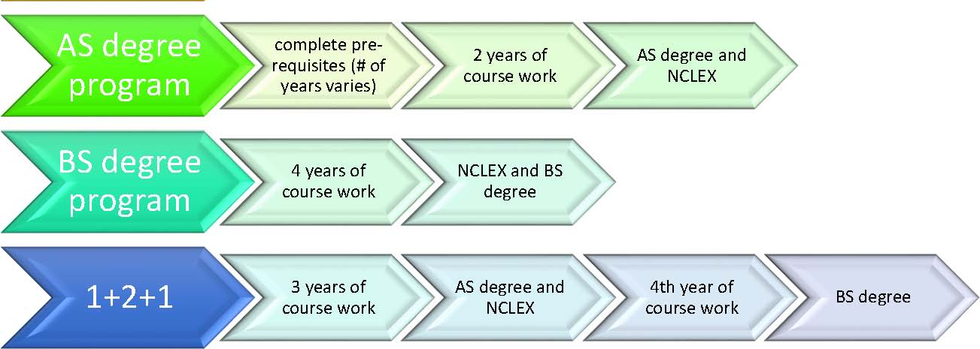
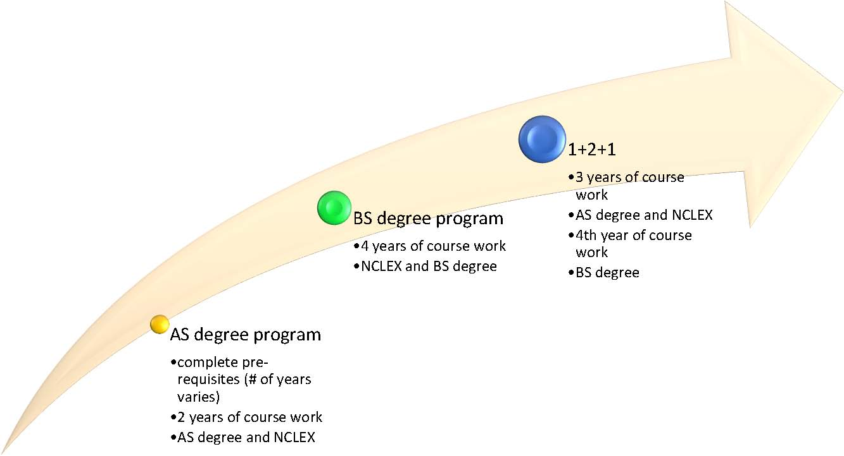

WHAT IS EXPECTED OF THE PROFESSIONAL NURSE?

Being licensed as a nurse in Arkansas is a privilege, and nurses are expected to conduct themselves in a professional manner at all times and abide by the rules and regulations that govern their practice. All nursing practice is performed in accordance with established standards, policies and procedures.

Ethics: Nurses are confronted with ethical issues in their everyday practice and have a code that guides their decision making. The Code of Ethics can be found at American Nurses Association http://www.nursingworld.org/codeofethics

Hours of work: This is dependent on the nurse's place of employment. In places where there is 24-hour care nurses are often assigned to work a shift for a set number of hours, such as an 8-hour shift, 10-hour shift or 12-hour shift. These shifts can involve day, evening or night hours. Some settings also require that nurses work weekends and holidays.

AVERAGE SALARIES OF NURSES IN Arkansas

Depending upon the region of the state and the setting in which a nurse works, salaries for RNs can range from $55,000 to $60,500. An average salary range for LPNs is $32,000 to $38,000.

Many employers offer flexible work schedules, child care, educational benefits, and bonuses.
Nurses who work in hospitals and nursing care facilities usually work in rotating shifts, covering all 24 hours. They may work nights, weekends, and holidays. They may be on call, which means they are on duty and must be available to work on short notice. Nurses who work in offices, schools, and other places that do not provide 24-hour care are more likely to work regular business hours.

Many nurses choose to work part-time so they can raise their families or continue on for further education.

MEN IN THE NURSING PROFESSION

In Arkansas, about 7% of active nurses are men, which is lower than the national average of 10.7%. (http://www.travelnursing.com/where-the-male-nurses-are/). The number of men in nursing has steadily increased over the last decade.

Men generally report that their reasons for choosing nursing as a career include helping people, the ability to make meaningful contributions to society, upward career mobility, financial security, and flexible scheduling. (http://aamn.org)
Many men have chosen nursing as a second career, following military training, or as a response to the recession. Some of the key benefits of choosing nursing as a career include having a stable career with many options for career paths, flexibility in scheduling, excellent benefits, and good salaries.

Special challenges men in nursing face include stereotyping, lack of male role models and mentors, marginalization, working in a traditionally female profession and lack of guidance information in high school. Topics of interest for high school boys considering nursing as a career may include detailed information about admissions requirements, internships, scholarships and mentoring programs for men. Key themes to include when discussing nursing as a career for men include: inclusive, non-gender specific details about the work nurses do, stable employment opportunities, high technical and hands-on skills, and autonomy.

Source: Zamanzadeh, V., Valizadeh, L., Negarandeh, R., Monadi, M., & Azadi, A. (2013). Factors Influencing Men Entering the Nursing Profession, and Understanding the Challenges Faced by Them: Iranian and Developed Countries’ Perspectives. Nursing and Midwifery Studies. http://www.ncbi.nlm.nih.gov/pmc/articles/PMC42289 Source: U.S. Air Force Photo by Staff Sgt. Joseph Swafford J
DISPELLING MYTHS ABOUT NURSING

Nursing school is for people who can’t get into medical school: Certainly not true! While the length of time from training to practice may be different, choosing a career in nursing or medicine is a personal decision and the pathways to each profession are similar in relation to the courses taken at the undergraduate level. Acceptance to nursing school and medical school are both competitive and require certain aptitudes and academic achievements to be successful.

I am not smart enough to get into nursing school: Nursing school is rigorous and requires many hours of study and discipline to be successful. However, with the proper preparation and course selections during middle and high school, most students can become qualified candidates for acceptance into nursing school.

Nursing is for Women Only: There are approximately 3 million RNs and 800,000 LPNs in the US, and nearly 9% (370,000) are men.

Male nurses are predominantly homosexual: A person’s sexual orientation is irrelevant to being a competent professional nurse and providing quality care. Men should not be dissuaded from considering a career in nursing for fear of being stereotyped in any way.

Female nurses are sex objects, promiscuous, “handmaidens” to physicians, “bedpan pushers”, drug addicts or “hell-raisers”. Most female (and male) nurses are upstanding, educated professionals who take the privilege of their nursing license seriously. The entertainment industry and media have portrayed nurses in negative ways which has led to a gross misrepresentation of the profession and a misunderstanding by the public.

I can go to a 2 year associate degree program to become an RN so why should I spend the time or money to go to a 4 year program? You can obtain the necessary basic training to apply for licensure as an RN through an accredited 2-year associate degree nursing program. However, the additional knowledge and skills learned at the baccalaureate level better prepares individuals to meet the challenges and requirements of a changing health care delivery system. Recent research has found that better patient outcomes, such as reduced infection rated, shorter hospital stays, and fewer patient falls, are achieved when patients are cared for by nurses with bachelor's degrees. The courses offered at the 4-year level Bachelor of Science in Nursing include research and statistics, community health, and leadership, to name a few, that enable the new nurse to gain the confidence and attributes needed for competent practice once licensed. All RNs, regardless of their area or setting of practice, lead teams and manage the care of patients and need to work collaboratively and collegially with all members of the healthcare team.

WHAT IS THE NATIONAL COUNCIL LICENSURE EXAM

A practicing nurse in any state requires you to have license. To obtain a nursing license you need to graduate from an approved nursing education program and pass an exam called National Council Licensure Examination (NCLEX).

What is NCLEX?

The National Council Licensure Examination, also known as the NCLEX exam, is a standardized computerized exam that each state board of nursing uses to determine whether or not a candidate is prepared for entry-level nursing practice. There are two types of National Council Licensure Examination (NCLEX) – one for registered nurses (RN) and one for practical nurses (PN). These are nationwide examinations for the licensing of nurses in the United States and Canada. Many nursing schools provide preparation classes for the NCLEX and there are also numerous online and hard copy study guides.

What does it do? Why is the NCLEX important to me?

A nursing license gives an individual the permission to practice nursing, granted by the state where he or she met the requirements. To practice as a nurse in any state you must pass the NCLEX examination. You take the NCLEX after you graduate from an accredited nursing program.
For more information about NCLEX visit https://www.ncsbn.org/index.htm

FOR MORE INFORMATION ABOUT NURSING VISIT:

Arkansas State Board of Nursing http://www.arsbn.org/
Arkansas Center for Nursing https://campaignforaction.org/arkansas-action-coalition-arkansas-center-nursing/
American Nurses Association http://www.nursingworld.org/
Arkansas Nurses Association http://arna.org/

*A full list of Arkansas approved nursing education programs is provided by the Arkansas State Board of Nursing and can be found on the Arkansas Center for Nursing, Inc. website as a supplement to this guide.

